Subgroup K

K.1 — [S13K1] Rotate NxN matrix 90° clockwise
Scenario (agritech):
Context:
A agritech UI component rotates square glyphs; engineers want an in-place matrix rotation utility.

Your Task:
Rotate an NxN matrix 90° clockwise, preferably in-place, with coverage for 1x1 and 2x2.

Data & Edge Cases:
Example 3x3 shown in sample.

AI Assistance Expectation:
Use AI to outline layer-by-layer swaps or transpose+reverse approach; add tests.

Constraints & Notes:
Include tests for small N.
Sample Input
[[1, 2, 3], [4, 5, 6], [7, 8, 9]]
Sample Output
[[7, 4, 1], [8, 5, 2], [9, 6, 3]]
Acceptance Criteria: In-place behavior correct
Task-1: prompt
Write a Python program to rotate an NxN matrix 90° clockwise in-placethe program should first take an integer N as input, representing the size of the square matrix.
then, it should take N rows of N integers each as input.
Finallyit should print the rotated matrix.
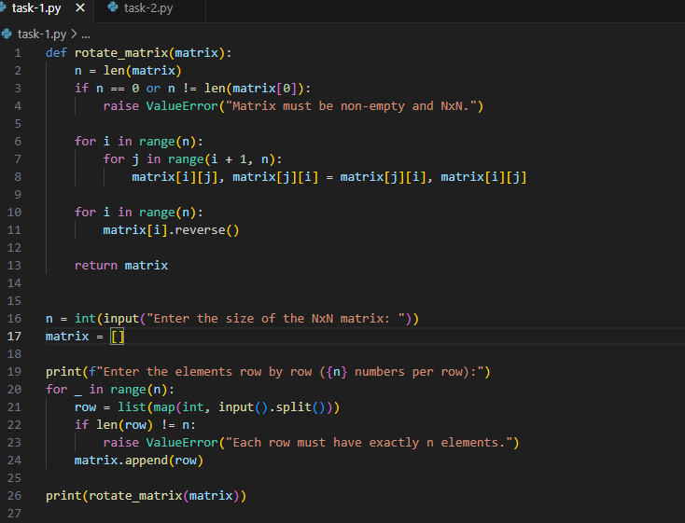
Output:
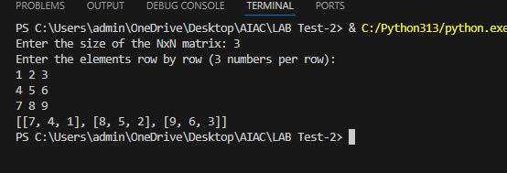

K.2 — [S13K2] Compute added/removed lines
Scenario (agritech):
Context:
Change review in agritech needs a function to show added/removed lines between versions.

Your Task:
Given `old` and `new` lists of lines, return (added, removed) preserving the display order.

Data & Edge Cases:
No duplicates in outputs; do not modify input.

AI Assistance Expectation:
Ask AI for an approach using sets but keep stable ordering via list comprehensions.

Constraints & Notes:
Do not show unchanged items.
Sample Input
old=['a','b','c'], new=['b','c','d']
Sample Output
added=['d'], removed=['a']
Acceptance Criteria: Stable ordering; correct diff
Task2:
Prompt
Write a Python program that reads two comma-separated lists from the user: the old list and the new list.
The program should compare both lists to detect differences between them.
It must find items present in the new list but not in the old list added items
It must also find items present in the old list but missing from the new list removed items
Finally, it should display the results in the format

